**NATIONAL INSTITUTE OF TECHNOLOGY SILCHAR**

**Cachar, Assam**

**B.Tech. IIIrd Sem**

**Subject Code:** CS211

**Submitted By:**

Name : Subhojit Ghimire

Sch. Id. : 1912160

Branch : CSE – B

/*

Q. Lab Question: Conversation of decimal number to Binary & Roman

*/

#include <stdio.h>

int main()

{

unsigned long num;

int selection;

printf ("Input the Number: ");

scanf ("%lu", &num);

printf ("Make Your Selection:\n");

printf ("1. Convert To Binary\n");

printf ("2. Convert To Roman\n");

printf ("> ");

scanf ("%d", &selection);

if (selection == 1)

{

if (num > 4294967295)

{

printf ("This program has the limit of converting decimal of upto 4,294,967,295 only.\n");

}

else

{

char bin ['!'];

unsigned long i;

for ( i=0; num != 0; ++i)

{

bin [i] = (num % 2) + '0';

num = num / 2;

}

bin [i] = '\0';

printf ("The Binary form is ");

for (i=i-1; i>=0; --i)

printf ("%c", bin[i]);

}

}

else if (selection == 2)

{

if (num > 3999999999)

{

printf ("This program doesn't support more than 3,999,999,999...");

}

else {

while(num != 0)

{

if (num >= 1000000000)

{

printf("[M]");

num -= 1000000000;

}

else if (num >= 900000000)

{

printf("[C][M]");

num -= 900000000;

}

else if (num >= 500000000)

{

printf("[D]");

num -= 500000000;

}

else if (num >= 400000000)

{

printf("[C][D]");

num -= 400000000;

}

else if (num >= 100000000)

{

printf("[C]");

num -= 100000000;

}

else if (num >= 90000000)

{

printf("[X][C]");

num -= 90000000;

}

else if (num >= 50000000)

{

printf("[L]");

num -= 50000000;

}

else if (num >= 40000000)

{

printf("[X][L]");

num -= 40000000;

}

else if (num >= 10000000)

{

printf("[X]");

num -= 10000000;

}

else if (num >= 9000000)

{

printf("[I][X]");

num -= 9000000;

}

else if (num >= 5000000)

{

printf("[V]");

num -= 5000000;

}

else if (num >= 4000000)

{

printf("[I][V]");

num -= 4000000;

}

else if (num >= 1000000)

{

printf("[I]");

num -= 1000000;

}

else if (num >= 900000)

{

printf("(C)[I]");

num -= 900000;

}

else if (num >= 500000)

{

printf("(D)");

num -= 500000;

}

else if (num >= 400000)

{

printf("(C)(D)");

num -= 400000;

}

else if (num >= 100000)

{

printf("(C)");

num -= 100000;

}

else if (num >= 90000)

{

printf("(X)(C)");

num -= 90000;

}

else if (num >= 50000)

{

printf("(L)");

num -= 50000;

}

else if (num >= 40000)

{

printf("(X)(L)");

num -= 40000;

}

else if (num >= 10000)

{

printf("(X)");

num -= 10000;

}

else if (num >= 9000)

{

printf("M(X)");

num -= 9000;

}

else if (num >= 5000)

{

printf("(V)");

num -= 5000;

}

else if (num >= 4000)

{

printf("M(V)");

num -= 4000;

}

else if (num >= 1000)

{

printf("M");

num -= 1000;

}

else if (num >= 900)

{

printf("CM");

num -= 900;

}

else if (num >= 500)

{

printf("D");

num -= 500;

}

else if (num >= 400)

{

printf("CD");

num -= 400;

}

else if (num >= 100)

{

printf("C");

num -= 100;

}

else if (num >= 90)

{

printf("XC");

num -= 90;

}

else if (num >= 50)

{

printf("L");

num -= 50;

}

else if (num >= 40)

{

printf("XL");

num -= 40;

}

else if (num >= 10)

{

printf("X");

num -= 10;

}

else if (num >= 9)

{

printf("IX");

num -= 9;

}

else if (num >= 5)

{

printf("V");

num -= 5;

}

else if (num >= 4)

{

printf("IV");

num -= 4;

}

else if (num >= 1)

{

printf("I");

num -= 1;

}

}

}

}

return 0;

}

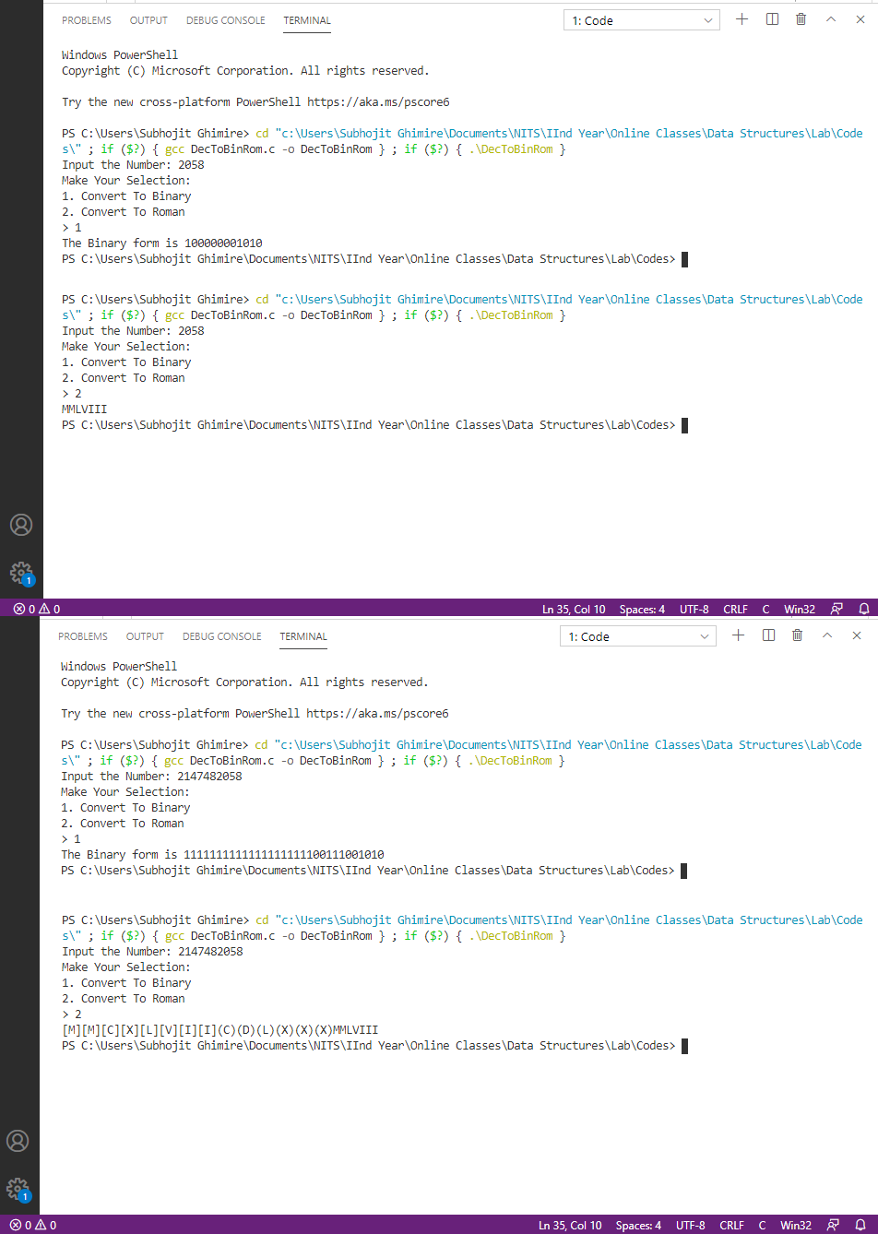OUTPUT: